GUIDELINES FOR AUTHORS PREPARING MANUSCRIPTS

Authors Name in Full

Affiliation, E-mail

ABSTRACT ... These mandatory guidelines are provided for preparation of papers accepted for publication. Reproduction is made directly from author-prepared manuscripts, in electronic or hardcopy form, in A4 paper size 297mm x 210mm (11.69 x 8.27 inches). …… Upload file name: PUID_family name.pdf e.g O700_Kim.pdf, P701_Park.pdf. The uploaded file should be converted to PDF format using a program supported by Adobe Acrobat. The specific explanation how to convert to PDF is at the bottom of this document. PUID can be checked from PDF files at the conference website.

**KEY WORDS:** Manuscripts, Proceedings, Guidelines for Authors, Styleguides, CDROM

# MANUSCRIPT

## General Instructions

Maximum paper length is restricted to **4 printed pages**. The paper should have the following structure:

Title of the paper

Authors and affiliation

Keywords (4-5 words)

Abstract (at least 100 words)

Introduction - including motivation, aims (and for long papers structure of the paper), overview and references to related work (in separate section)

Main body - explanation of methods, algorithms, data used, instrumentation (sensors, systems, etc.), results and discussion

Conclusions

References

Acknowledgements

All papers should be sent to the meeting organisers in digital form. However, if in exceptional circumstances, the paper cannot be prepared digitally, it must be prepared on A4 paper according to these guidelines, and sent to the organisers for scanning.

## Page Layout, Spacing and Margins

The paper must be compiled in one column for the Title and Abstract and in two columns for all subsequent text. All text should be single-spaced unless otherwise stated herein. Left and right justified typing is preferred.

## Preparation in Electronic Form

The size of the paper in PDF format should not exceed the limit in Mb specified by the organizer of the meeting.

Table 1. Margin settings for A4 size paper

|  |  |  |
| --- | --- | --- |
| Setting | A4 size paper | |
|  | mm | inches |
| Top | 25 | 1.0 |
| Bottom | 25 | 1.0 |
| Left | 20 | 0.8 |
| Right | 20 | 0.8 |
| Column Width | 82 | 3.2 |
| Column Spacing | 6 | 0.25 |

## Hardcopy Preparation

If the paper is transmitted to the meeting organisers in hardcopy version only, it must conform in appearance to these guidelines for authors. Each page must be output on a high quality computer printer. Do not typethe page number on the manuscript sheet.

## Length and Font

All manuscripts, except Invited Papers, submitted in hard copy or electronically are limited to a size of no more than four (4) single-spaced pages (A4 size) in the printed version. For the printed version, the font type Times New Roman with a size of ten (10) points is to be used.

# TITLE AND ABSTRACT BLOCK

## Title

The title should appear centered in **BOLD CAPITAL LETTERS** without underlining, near the top of the first page of the paper. The font type Times New Roman with **a size of 16 points is to be used**. Use more than one line if you wish, but always use single-spacing. After one blank line, type the author(s) name(s), affiliation and mailing address (including e-mail) in upper and lower case letters centered under the title. In the case of multi-authorship, group them by firm or organization as shown in the title of these Guidelines.

## Abstract

Leave two blank lines under the key words. Type "**ABSTRACT:**" flush left in bold Capitals followed by one blank line. Start now with a concise Abstract which presents briefly the content and very importantly, the news and results of the paper in words understandable also to non-specialists.

# MAIN BODY OF TEXT

Type text single-spaced, **with** one blank line between paragraphs and following headings. Start paragraphs flush with left margin.

## Headings

**MAJOR HEADINGS**

Major headings or section headings are to be centered, in bold capitals without underlining, after a triple line space (two blank lines) and followed by a double line space (one blank line). Latter is done automatically when using the provided Word template file.

**Subheadings**

Type subheadings flush with the left margin in bold upper case and lower case letters. Subheadings are on a separate line between two single blank lines. The blank line after is added automatically when using the provided Word template file.

**Subsubheadings:** They are to be typed in bold upper case and lower case letters after one double line space (one blank line) flush with the left margin of the page, with text following on the same line. Subsubheadings may be followed by period or colon, they may also be the first word of the paragraph's sentence.

Decimal numbering of all sections is recommended (with the exception of the sections “Acknowledgements” and “References”). If bold printing is not available to you, use underlining, instead, but only for subheadings and subsubheadings, not for Major Headings.

## Illustrations

### **Placement**: Figures must be placed in the appropriate location in the document, as close as practicable to the reference of the figure in the text. While figures and tables are usually aligned horizontally on the page, large figures and tables sometimes need to be turned on their sides. If you must turn a figure or table sideways, please be sure that the top is always on the left-hand side of the page.

### **Captions**: All captions should be typed in upper and lower case letters, centered directly beneath the illustration. Use single spacing if they use more than one line. All captions are to be numbered consecutively, e.g. Figure 1, Table 2, Figure 3.

### **Line Drawings**: Drawings in papers prepared in digital form must be in the appropriate location in the document.

For the best reproduction of line drawings of papers prepared in hardcopy, the original drawings should be made on white paper and carefully mounted in an appropriate position within the text. (Use rubber cement or pressure sensitive wax, not glue, mucilage or scotch tape).



Figure 1. Figure placement and numbering.

Do not use any low contrast photocopying process, because the figures will reproduce poorly after scanning.

### **Photographs**: For papers prepared in digital form, images must be placed in appropriate positions in the paper. The resolution should be sufficient to allow proper quality hard copy reproduction of the paper (i.e. about 600dpi). For papers prepared in hardcopy, paste original photographs into the manuscript pages. Type the caption directly under photos.

### **Tables**: Tables should be produced directly within the text. Each table should have a number and a caption.

### **Copyright**: If your article contains any copyrighted illustrations or imagery, please include a statement of copyright such as: © SPOT Image Copyright 19xx (fill in year), CNES. It is the author's responsibility to obtain any necessary copyright permission. The copyright of your article remains with you.

## Equations, Symbols and Units

### **Equations**: Equations should be numbered consecutively throughout the paper. The equation number is enclosed in parentheses and placed flush right. Leave two blank lines before and after equations. E.g.

 (1)

where *c* = focal length

x, y = image coordinates

X0, Y0, Z0 = coordinates of projection center

X’, Y’, Z’ = object coordinates in ground

coordinate system

### **Symbols and Units**: Use the SI (Systeme Internationale) Units and Symbols. Unusual characters or symbols should be explained in a list of nomenclature.

## References and/or Selected Bibliography

References should be cited in the text, thus (Smith, 1987b; Moons, 1997), and listed in alphabetical order in the reference section, leaving a blank line between references. The following arrangements should be used:

**References from Journals**:

Smith, J., 1987a. Close range photogrammetry for analyzing distressed trees. *Photogrammetria*, 42(1), pp. 47-56.

Names of journals can be abbreviated according to the "International List of Periodical Title Word Abbreviations". In case of doubt, write names in full.

**References from Books**:

Smith, J., 1989. *Space Data from Earth Sciences*. Elsevier, Amsterdam, pp. 321-332.

**References from Other Literature**:

Smith, J., 1987b. Economic printing of color orthophotos. Report KRL-01234, Kennedy Research Laboratories, Arlington, VA, USA.

Smith, J., 2000. Remote sensing to predict volcano outbursts. In: *The International Archives of the Photogrammetry, Remote Sensing and Spatial Information Sciences*, Kyoto, Japan, Vol. XXVII, Part B1, pp. 456-469.

## Acknowledgements (optional)

Acknowledgements of support for the project/paper/author are welcome.

**How to Create a Production-Ready PDF File of Your Final Submission**

ALL FONTS MUST BE EMBEDDED IN THE PDF FILE. THIS INCLUDES ALL FONTS CONTAINED IN THE GRAPHIC IMAGES AS WELL. THE PDF FILE MUST BE CREATED USING A PROGRAM SUPPORTED BY ADOBE ACROBAT. AND PLEASE MAKE SURE ALL IMAGES INCLUDED IN YOUR FINAL SUBMISSION.

**How to Embed Fonts**

You will be converting your source file to PDF for final submission to the proceedings. When creating the PDF file it is important to ensure that you embed all fonts. In order to ensure there is no loss if information in the PDF file, all fonts must be embedded. If your fonts are not embedded, your paper will not print correctly. Fonts should be embedded when creating the initial PDF file.

**Converting Word to PDF**

When creating a PDF file from a Word file the settings to embed the fonts should be done in Word. When printing to PDF from Word, the options are chosen when creating your print settings.

Below is how this should be done:

In the print dialog box

Select "Adobe PDF."

Select "Properties."

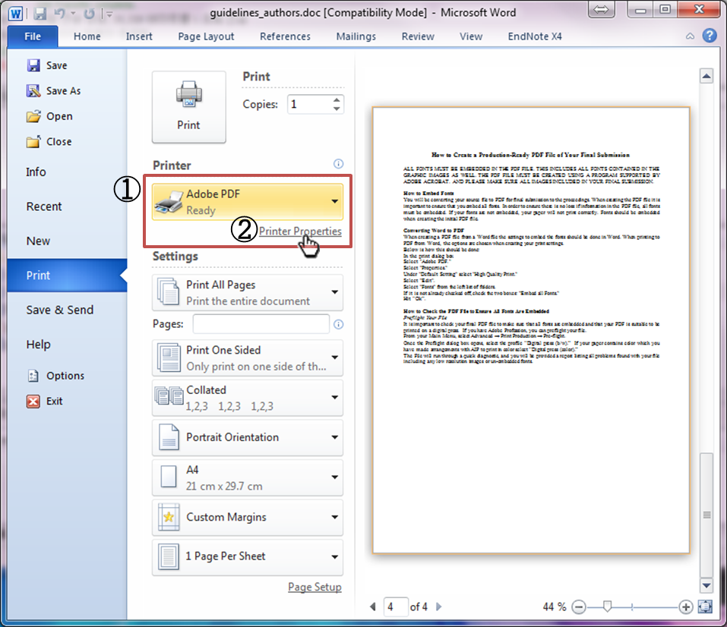

Under "Default Setting" select "High Quality Print."

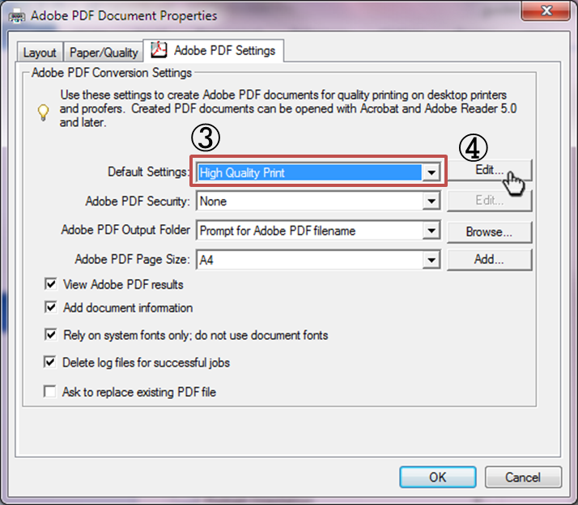

Select "Edit".

Select "Fonts" from the left list of folders.

If it is not already checked off, check the two boxes: "Embed all Fonts."

Hit “Ok”.

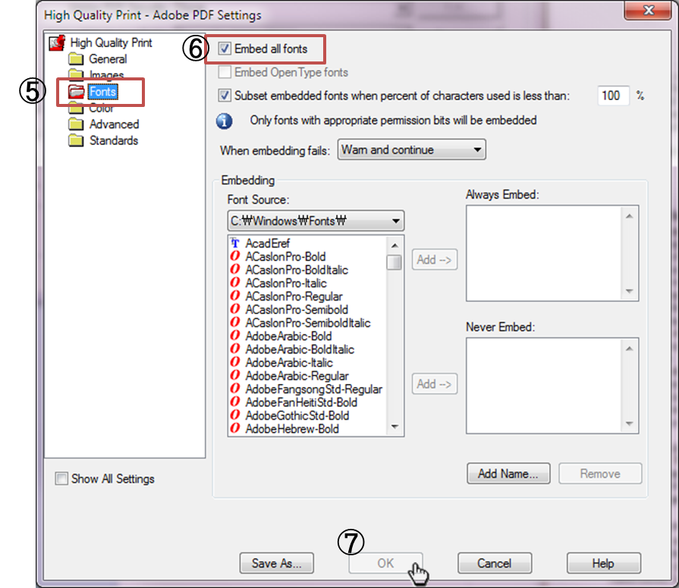

**How to Check the PDF File to Ensure All Fonts Are Embedded**

*Preflight Your File*

It is important to check your final PDF file to make sure that all fonts are embedded and that your PDF is suitable to be printed on a digital press. If you have Adobe Profession, you can preflight your file.

From your Main Menu, select Advanced → Print Production → Pre-flight.

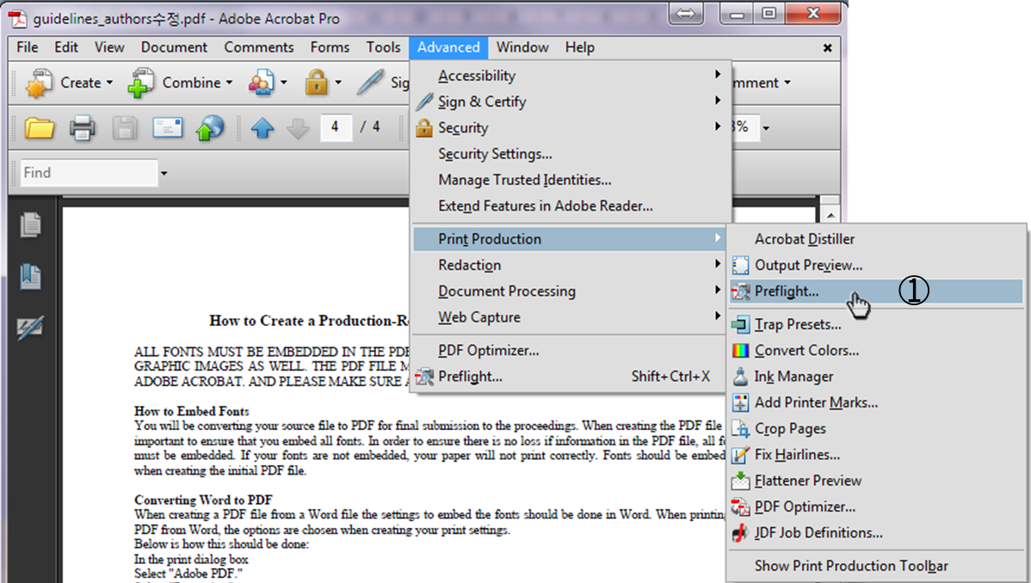

Once the Preflight dialog box opens, select the profile “Digital press (b/w).” If your paper contains color which you have made arrangements with AIP to print in color select “Digital press (color).”

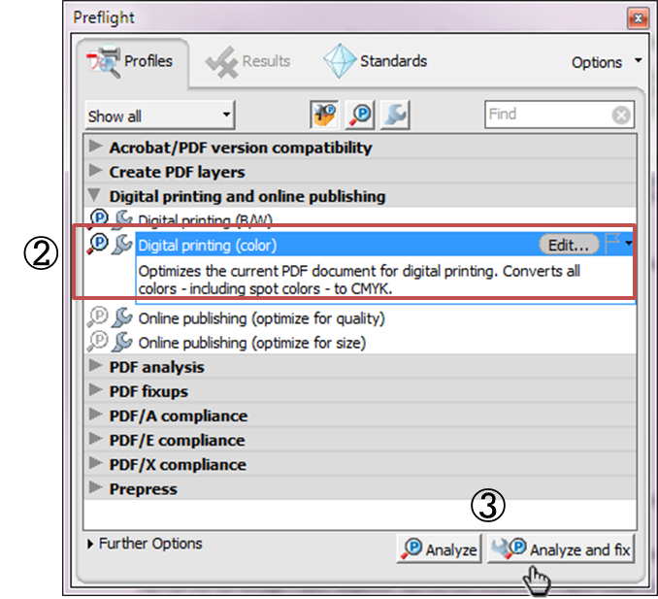

The File will run through a quick diagnostic, and you will be provided a report listing all problems found with your file including any low resolution images or un-embedded fonts.